Building Oncology Drug and Drug Drug Interaction Adverse Events Monitoring Using OpenFDA database

Weilu Han

**Background**

An adverse drug event (ADE) is an injury resulting from medical intervention related to a drug. Adverse events account for approximately 125,000 hospital admissions and an estimated 1 million emergency department visits[1]. In oncology ADRs are generally considered inevitable with common symptoms like nausea and vomiting.

The Adverse Event Reporting System (AERS) is a computerized information database designed to support the Food and Drug Administration's (FDA) post-marketing safety surveillance program for all approved drug and therapeutic biologic products. The FDA uses AERS to monitor for new adverse events and medication errors that might occur with these marketed products.

**Objective**

The main objective of this study is to evaluation the association of Oncology medicine (LYNPARZA, TAGRISSO,IRESSA) and common adverse events. Particularly, I am interested to answer:

1. What is the risk of adverse events associated with LYNPARZA, TAGRISSO and IRESSA for each month in 2019?
2. What are the common drug combinations of LYNPARZA, TAGRISSO and IRESSA?
3. What are the adverse events most likely seen in common drug-drug interactions for LYNPARZA, TAGRISSO and IRESSA?

**Data Downloading**

The data is downloaded from OpenFda website searching for receive date between January and December 2019 and drug indication including strings like cancer and melanoma. All the data are stored in MongoDB with total 66741 reports.

**Data Cleaning**

Duplicated reports

The duplicated report is defined as reports which has exactly the same onset age, sex, primary source country, medical product and drug reactions. After removing the duplicated reports, 60916 reports are retained.

Entry Error

Patient sex was wrongly labeled 0 in some safety reports. Age above 100 are suspected to be wrongly labeled.

**Exploratory Analysis**

The majority of the AE reports come from United states flowed by Japan and Germany. In the US, the top disease areas are Breast Cancer ,ovarian cancer, and lung cancer. Over 45% of the patients are above age 60.

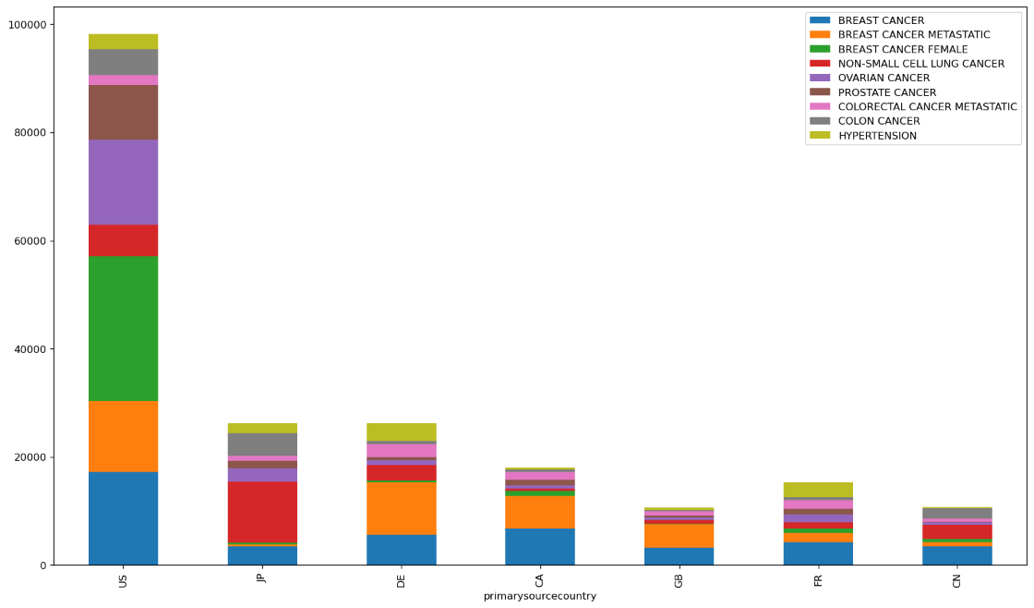

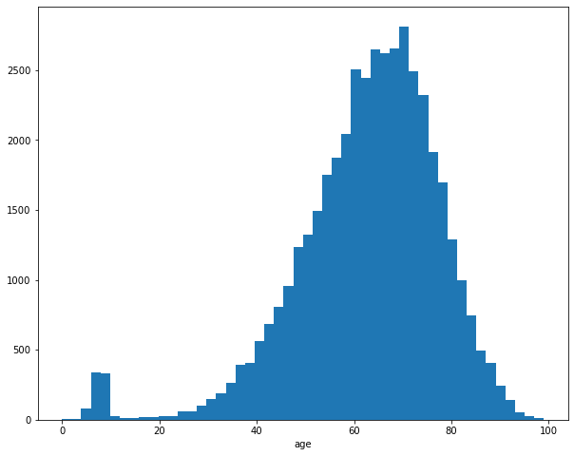

**Methods**

Proportional Reporting Ratio (PPR) is used in quantitative screening of spontaneous reports. RR is the degree of disproportionate reporting of an adverse event for a product of interest compared to this same event for all other products in the database[2].

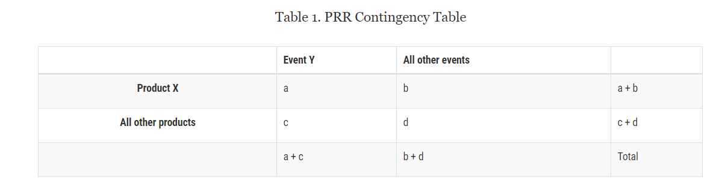

PRR = [a/(a+b)] / [c/(c+d)]

95% CI of PRR are also calculated. For this study, I focused on four adverse events which are Nausea, Vomiting, Fatigue and Death.

Drug-Drug combination are also created for each of LYNPARZA, TAGRISSO and IRESSA. For instance, given a safety report, if the patient has taken LYNPARZA, we generate combinations of 2 drugs by associated LYNPARZA with rest of the drug taken by the patient.

**Results**

For Drug LYNPARZA, Death and Fatigue are all under PRR 2 in 2019. There are some observations above 2 for Vomiting and Nausea.

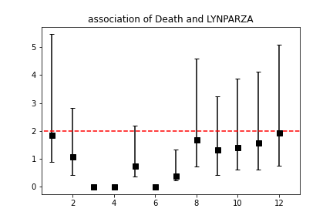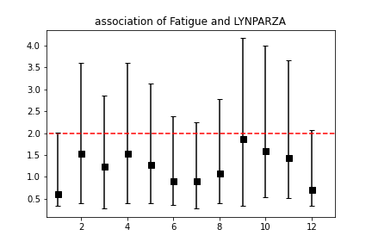

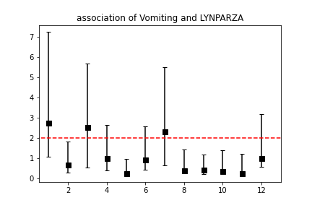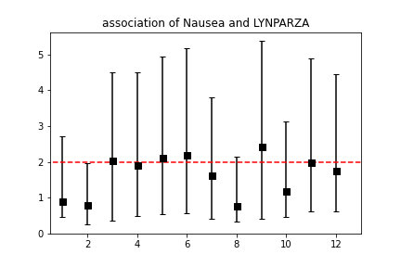

TAGRISSO are most likely associated with Death in January, May, and October, while less likely associated with Fatigue Vomiting and Nausea.

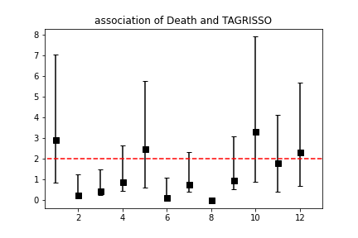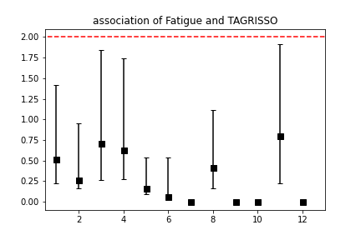

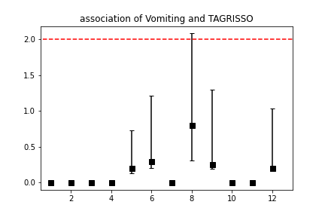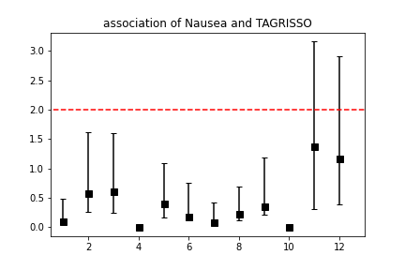

Almost all the risk of AE for IRESSA are low.

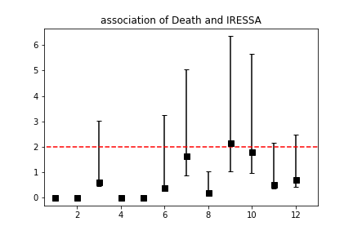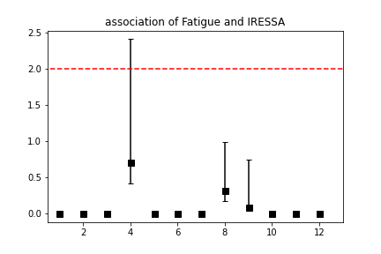

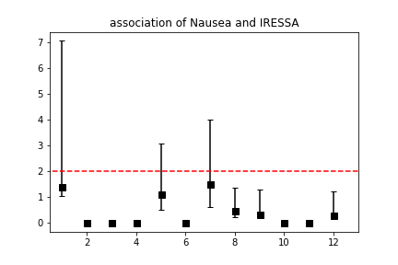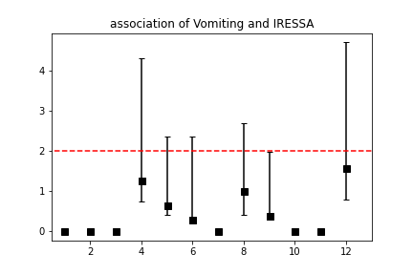

**Drug Drug Interaction:**

Top 5 drug combinations for each Oncology medicine.

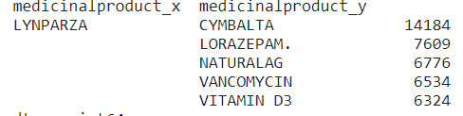

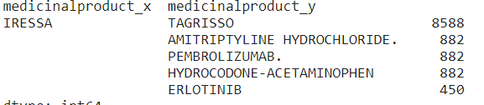

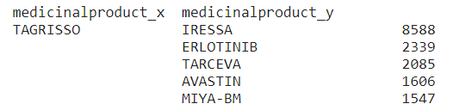

**Example of combination of IRESSA and other common drugs in 2019**

|  |  |  |  |  |  |
| --- | --- | --- | --- | --- | --- |
|  | prr | l | u | drug_interaction | event |
|  | 0.591046 | 0.550407 | 0.634685 | TAGRISSO | Fatigue |
|  | 0.253737 | 0.233637 | 0.275566 | TAGRISSO | Nausea |
|  | 0.63354 | 0.595859 | 0.673604 | TAGRISSO | Vomiting |
|  | 0 | 0 | 0 | TAGRISSO | Death |
|  | **14.96023** | **13.8639** | **16.14325** | **AMITRIPTYLINE HYDROCHLORIDE.** | **Fatigue** |
|  | **3.944742** | **3.542055** | **4.393208** | **AMITRIPTYLINE HYDROCHLORIDE.** | **Nausea** |
|  | **7.694056** | **7.014784** | **8.439105** | **AMITRIPTYLINE HYDROCHLORIDE.** | **Vomiting** |
|  | 0 | 0 | 0 | AMITRIPTYLINE HYDROCHLORIDE. | Death |

**Limitations**

One limitation of the study is that the AE might be underreported in the database. Since there is one drug reaction field for all the drugs taken, we are not clear that which drug cause which specific reaction.

Another limitation is that we consider different products name as different drug. Normalization of drug names should be executed to improve the accuracy.

PRR has its limitations with its denominator tend to be inflated. Looking forward, I am interested to detect the signal by Huang’s likelihood ratio test[3]. Overall, our results can be generalized.

1. <https://www.healthypeople.gov/2020/data-source/adverse-event-reporting-system>
2. <https://www.fda.gov/science-research/data-mining/data-mining-fda-white-paper>
3. <https://amstat.tandfonline.com/doi/abs/10.1198/jasa.2011.ap10243>